**Engine Control Unit (ECU).**

*Main Components of Engine Control Unit (ECU):*

**1. *Sensors:\***

**- *Engine Speed Sensor (Crankshaft Position Sensor):\*** Measures the rotational speed of the engine.

**- *Throttle Position Sensor:\*** Monitors the position of the throttle pedal to determine engine load.

**- *Mass Air Flow Sensor**:* Measures the amount of air entering the engine.

**- *Engine Coolant Temperature Sensor:\*** Monitors the temperature of the engine coolant.

**- *Oxygen (O2) Sensors:\*** Measure the oxygen content in the exhaust gases to adjust fuel mixture.

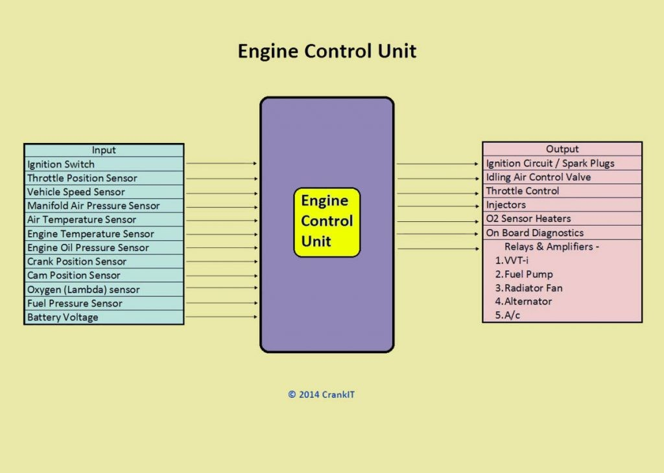

**2. *Actuators:\***

**- *Fuel Injectors:\*** Control the amount of fuel injected into the engine cylinders.

**- *Idle Air Control Valve:\*** Adjusts the engine idle speed.

**- *Ignition Coils:\*** Triggered to ignite the air-fuel mixture in the engine cylinders.

**- *Variable Valve Timing Actuators (if equipped):\*** Adjust valve timing for optimal engine performance.

**3. *Communication Protocols:\***

**- *CAN (Controller Area Network):\*** Used for communication between various ECUs and modules within the vehicle.

**- *LIN (Local Interconnect Network):\*** *Used* for communication with sensors and actuators that don’t require high-speed data transfer.

**\*Operation of Engine Control Unit (ECU):\***

The ECU's primary function is to optimize engine performance, fuel efficiency, and emissions by processing data from various sensors and controlling actuators. Here’s how it typically operates:

**1. *Data Acquisition:\*** Sensors continuously monitor parameters such as engine speed, throttle position, airflow, temperature, and exhaust composition.

**2. *Data Processing:\*** The ECU receives sensor data and processes it using control algorithms stored in its memory. These algorithms calculate the optimal air-fuel mixture, ignition timing, and other parameters based on current operating conditions.

**3. *Actuator Control**:* Based on the processed data, the ECU sends commands to actuators like fuel injectors, ignition coils, and others to adjust their operation. For example, it adjusts the fuel injection timing and duration to maintain the correct air-fuel ratio.

**4. *Communication with Other Systems:\*** The ECU communicates with other vehicle ECUs (such as Transmission Control Unit, Body Control Module) via CAN or LIN networks to coordinate vehicle functions and ensure smooth operation.

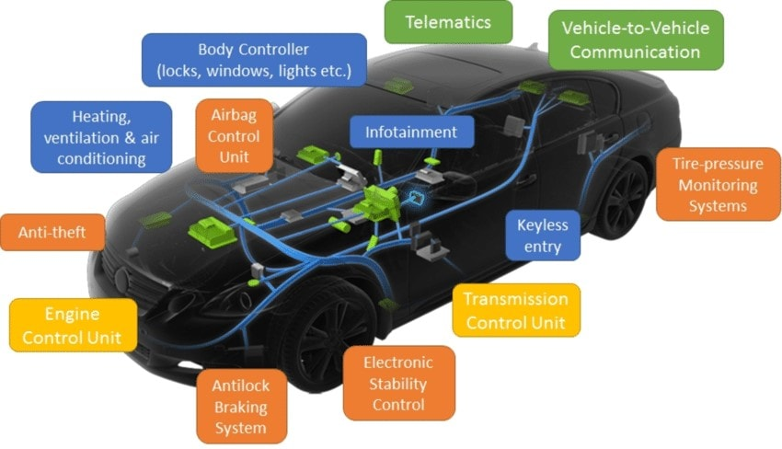

**\*Example Scenario:\***

Imagine you are driving uphill. As you press the accelerator pedal, the throttle position sensor sends signals to the ECU, indicating increased throttle input. The ECU then:

- Increases the fuel injection duration to provide more fuel to the engine.

- Adjusts the ignition timing to optimize power output.

- Monitors the engine speed and temperature to prevent overheating or excessive strain.

If the road suddenly levels out, you release the accelerator pedal. The throttle position sensor signals decrease, prompting the ECU to:

- Reduce fuel injection to save fuel.

- Adjust idle speed and timing for smoother operation during deceleration.

\***Impact on Vehicle Performance, Safety, or Driver Experience:\***

The ECU's precise control over engine parameters ensures optimal performance, fuel efficiency, and emissions compliance under various driving conditions. This leads to smoother acceleration, better fuel economy, and reduced emissions, enhancing both driver comfort and environmental friendliness.

Common failure modes of the ECU include sensor malfunction (e.g., faulty throttle position sensor) or internal ECU hardware failure. Modern ECUs are designed with redundancy and diagnostic capabilities:

**\*Potential Failure Modes and Mitigation:\***

**- *Redundancy:\*** Some critical sensors may have duplicate inputs or backup sensors to ensure continuous operation.

**- *Diagnostic Codes:\*** The ECU monitors its own operation and stores diagnostic trouble codes (DTCs) when abnormalities are detected, aiding in troubleshooting and repair.

**- *Fail-Safe Modes:\*** In case of sensor failure, the ECU may use default values or predefined strategies to allow the vehicle to continue operating with reduced performance until repairs can be made.

In conclusion, the Engine Control Unit (ECU) plays a crucial role in optimizing engine performance and efficiency while ensuring reliability and safety through advanced control algorithms and communication with other vehicle systems.